Ideation Phase
Empathize & Discover

Date | 7 November 2025
Team ID | NM2025TMID09184
Project Name | Laptop Request Catalog Item
Maximum Marks | 4 Marks

Empathy Map Canvas:
In the Empathize & Discover phase, the team explored how employees and IT staff currently handle laptop requests within the organization.
Through observation and discussions, it was discovered that the existing process is manual, time-consuming, and prone to errors.
Employees often struggle with unclear request formats, while IT support teams face difficulties verifying details, managing approvals, and ensuring proper tracking. Example:Laptop Request Catalog Item
Understanding these user frustrations and workflow gaps revealed that a ServiceNow-based Laptop Request Catalog Item would provide structure, automation, and visibility — improving both user satisfaction and operational efficiency.
Key Insights:
- Employees are uncertain about what information to include when requesting laptops.
- IT staff experience delays and confusion due to missing or incomplete request details.
- The lack of dynamic forms and validation leads to repetitive communication and longer resolution times.
- Manual tracking of requests causes governance and data consistency issues.

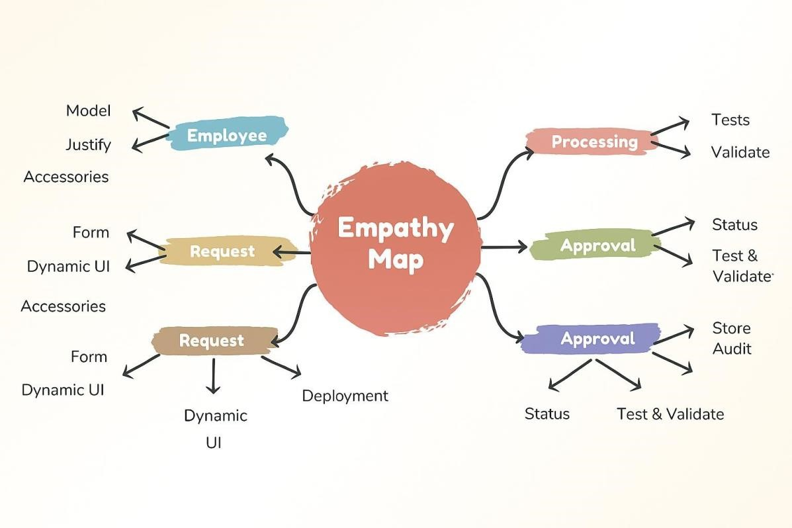
Example: Laptop Request Catalog Item

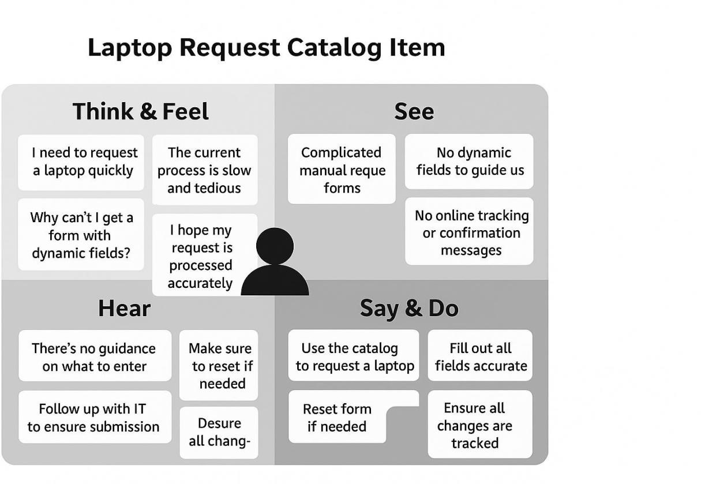

By deeply understanding users through the empathy mapping process, the
team identified key frustrations such as manual workflows, missing information, and lack of transparency in the laptop request process.
These insights guided the design of an automated Service Catalog Item in ServiceNow that incorporates dynamic fields, validation policies, and UI actions like form reset.The result is a streamlined, user-friendly, and efficient system that reduces errors, speeds up approvals, and enhances user confidence in IT service delivery.

